**Create a Virtual Network**

**Add 3 subnets**

**FrontEnd**

**BackEnd**

**VirtualAppliance-subnet > middleware**

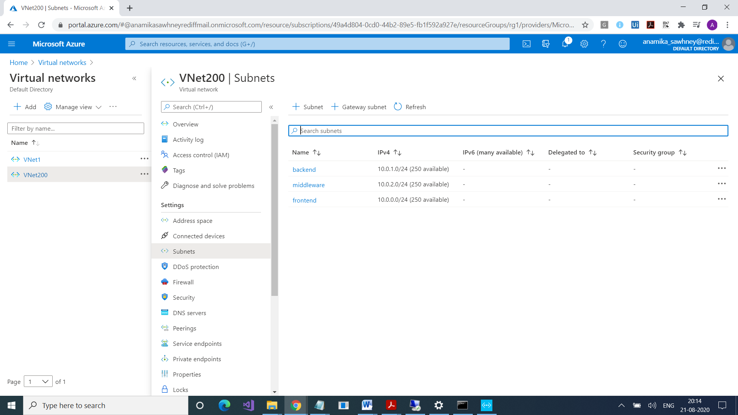

So, we have a VNet with three subnets

Now we will provision three VM’s in the three subnets

In VMNVA . Only rdp

**Create Route Table, (For passing packets from frontend to backend)**

**Add a Route to the Route Table**

**We have to attach this route table to frontend**

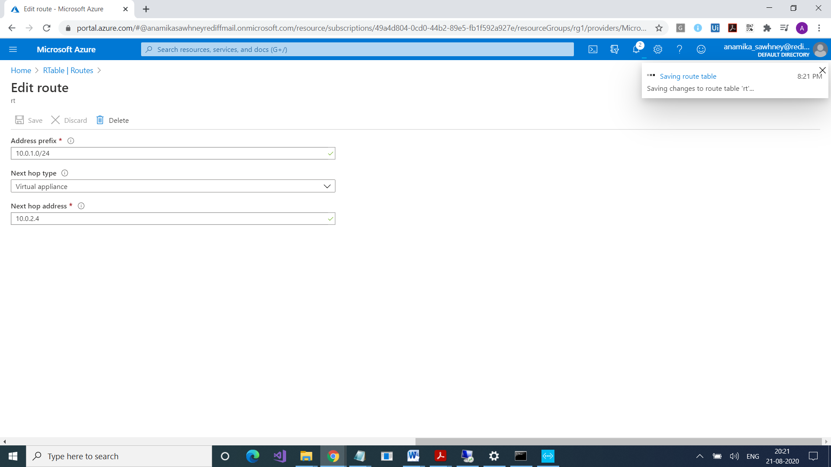

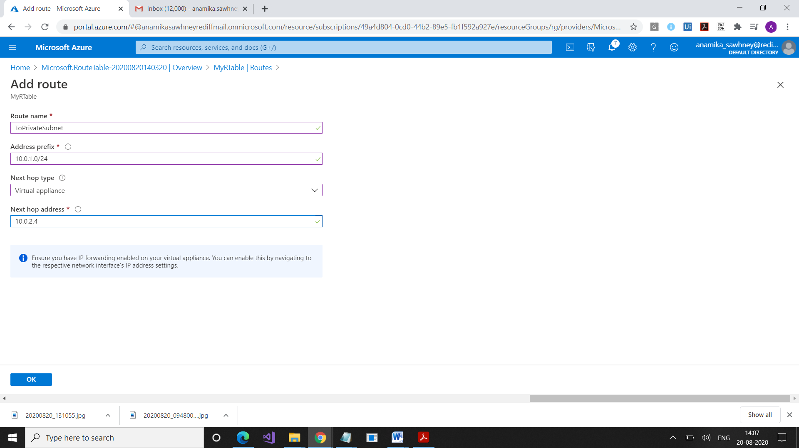

Add this route table to the public subnet

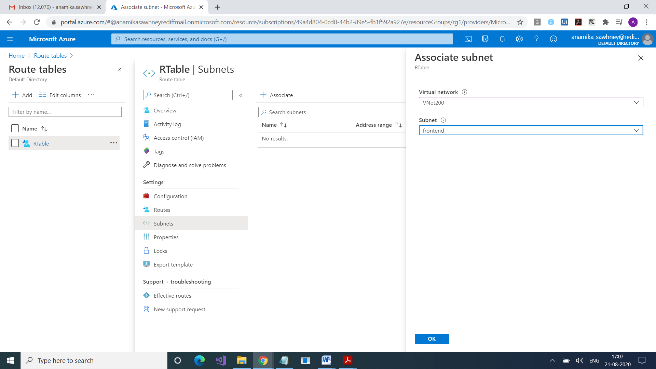

Now go to virtual machine

NVA

Go to the Network Interface of NVA VM

Go to IP Configurations

Enable IP Forwarding

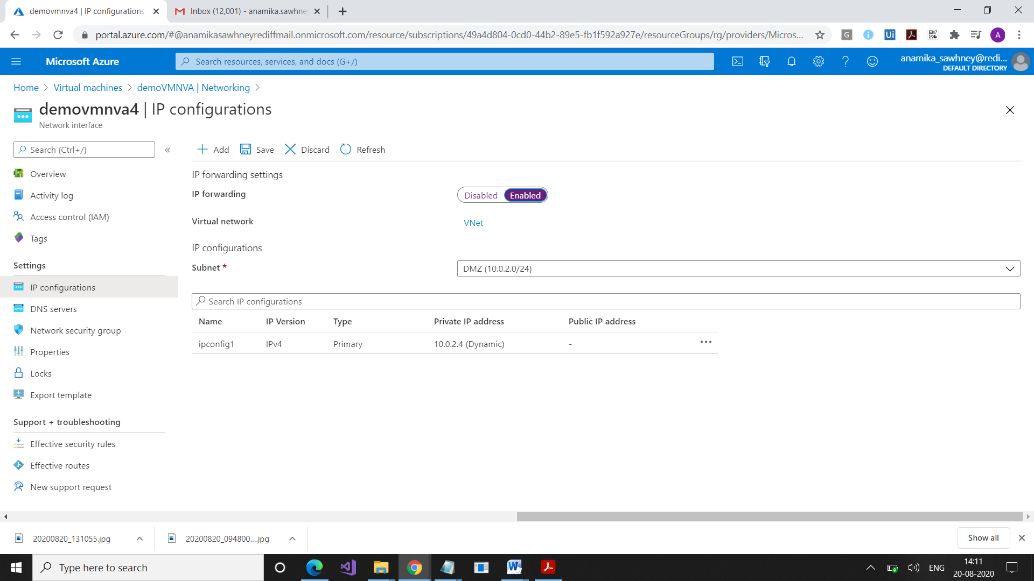

Go to Public Virtual Machine

PS C:\Users\anamika> Set-ItemProperty –Path HKLM:\SYSTEM\CurrentControlSet\Services\Tcpip\Parameters –Name IpEnableRouter –Value 1

PS C:\Users\anamika>

<https://docs.microsoft.com/en-us/azure/virtual-network/tutorial-create-route-table-portal>